

Web-Based Platform for JKL Cleaning SERVICE

**Phase 3: Final Design and Project Timeline**



December 1, 2023

**Group 6**

EUGENIO, SHA

GONZALES, LANCE

KAUR, PAWANDEEP

SINGH, NAVRAJ

SINGH, SEHAJBIR

Table of Contents

Statement of the Project and Project Sponsor 2

Revised Use Case Diagram 7

Use Case Descriptions in Extended Format 9

Preliminary User Interface Design 30

Data Storage and Persistence 44

Entity Diagram 46

Revised Class Diagram 47

System Architecture and Patterns 48

Sample Design Pattern for JKL Cleaning Service 49

Sequence Diagrams 50

Activity Diagrams 53

Small System Prototype 55

Work Breakdown and Gantt Chart 55

Work Breakdown 55

LOC Estimation Table 57

Gantt Chart 58

Appendix 59

Team Constitution 59

Bibliography 62

# Statement of the Project and Project Sponsor

**Project Name**

JKL Cleaning Service Web-based Platform

**Project Sponsor**

JKL Cleaning Service

**Sponsor's Business**

JKL Cleaning Service is a tailored cleaning service provider that places a strong emphasis on detail [1].

**Sponsor's Current System**

JKL Cleaning Service currently handles its operations mostly through manual procedures and communication. Customers usually call, email, or make in-person arrangements to book cleaning services. Additionally handled manually are Employee communication, assignments, and timetables. The process is not automated or digitalized, which makes it less effective and more prone to mistakes.

**Proposed solutions**

Our team will provide web platform development for JKL Cleaning Service. This platform will offer a comprehensive solution to address the challenges faced by sponsors, including features such as online booking, staff management, customer notifications, customer reviews and ratings, photo verification, appointment management, and more.

The platform will streamline the entire business process, enabling customers to book services online, specify their requirements, and select a convenient appointment time. Employees will have access to a secure portal where they can view their schedules, report work progress, and communicate with management. This transition will significantly enhance the efficiency and customer experience of JKL Cleaning Service, replacing manual processes with an easy-to-use digital platform that ensures data accuracy. The solution aims to increase productivity, reduce errors, and improve overall service quality.

The web platform will include a secure database for storing customer and Employee information, an authentication system for both customers and Employees, and a user-friendly interface tailored to meet the specific needs of each group. The platform's features will be customized to provide a seamless experience for customers seeking cleaning services and staff managing their schedules and tasks. The platform will prioritize user-centric design, emphasizing ease of use and accessibility.

It was essential for us to fully understand the existing business processes and workflows within JKL Cleaning Service to effectively scale our solution. We will work closely with sponsors to ensure the platform aligns with their unique requirements and challenges. This project goes beyond building a website; it's about transforming the way JKL Cleaning Service operates and serves its customers.

**Project Objectives**

JKL Cleaning Service is a reputable cleaning service provider known for its attention to detail and personalized approach. The goal of this project is to create a web platform that will enhance the operations of JKL Cleaning Service, streamline customer interactions, enable effective Employee management, and comprehensively improve the overall service experience for customers. The platform will offer customer booking features, Employee management tools, time tracking, customer notifications, customer reviews, photo verification, appointment management, staff profiles, an interactive pricing tool, and appointment history.

**Must-have Features**

Mandatory features that must be incorporated into the application.

* **Online Booking:** Develop a user-friendly customer interface that allows clients to book cleaning services online, including specifying service details, dates, preferred time slots, and special requests.
* **Hours Tracking:** Provide tools for Employees to track their work hours and report progress on tasks and assignments.
* **Customer Notifications:** Develop a notification system to keep customers informed about their bookings, appointment reminders, and service status.
* **Customer Reviews and Ratings:** Implement a feature that allows customers to leave reviews and ratings after cleaning services, enhancing transparency and trust. Implement feedback surveys after each cleaning service to continuously improve service quality.
* **Photo Verification:** Require Employees to take photos of the cleaned areas to show customers as proof of service completion.
* **Appointment Cancellation and Rescheduling:** Enable customers to cancel or reschedule appointments with a minimum notice period of at least 3 days before the appointment.
* **Location-Based Booking:** Enable customers to book Employees based on their current location, with the default location being the Employee's home address when they are not at a customer's place cleaning. This is tracked using zip codes.
* **Employee Cancellation:** Allow Employees to cancel a cleaning booking with at least 3 days' notice.
* **Employee Profiles:** Create profiles for Employees with details, such as their experience, certifications, and customer reviews. This helps customers make more informed choices.
* **Interactive Pricing Calculator:** Incorporate a pricing calculator that allows customers to estimate the cost of cleaning services based on the area measurement.
* **Appointment History:** Enable customers to access their appointment history, including details of past services and Employees.
* **Employee Management:** Create a secure Employee portal to manage schedules, assignments, and reporting, improving efficiency and communication among the workforce.

**Should-have Features**

Priority features that are not necessary for the application to work.

* **Payment Processing:** Implement secure and reliable payment processing functionality for customer payments, enabling various payment methods.
* **Recurring Booking:** Offer customers the option to set up recurring cleaning appointments, such as weekly, bi-weekly, or monthly, without the need to rebook each time.

**Could-have Features**

Optional features that could be incorporated into the application.

* **Employee Selection:** Allow customers to choose which Employee they want to book based on Employee availability and location.
* **Appointment Swapping:** Enable Employees to swap cleaning appointments with other Employees when needed or in an emergency.
* **Real-Time Tracking:** Implement a real-time tracking feature that allows customers to track the location and progress of the Employee en route to their location. This adds transparency and peace of mind for customers.
* **Instant Messaging:** Provide a chat or messaging system that enables direct communication between customers and Employees. This can be useful for discussing specific cleaning instructions or any changes in the appointment.
* **Invoicing and Receipts:** Allow customers to access and download invoices and receipts for their bookings. This adds professionalism and convenience.
* **Complaint Resolution:** Develop a system for handling customer complaints or concerns promptly and professionally.
* **Integration with Google Maps:** Allow customers to see Employee locations on Google Maps when they're on the way to the appointment.

**Project Scope and Deliverables**

* Design and development of a responsive web-based platform.
* Implementation of booking functionality and Employee scheduling.
* Integration with a database to store customer, Employee, and job-related data.
* User authentication and authorization systems for both customers and Employees.
* Implementation of customer reviews and ratings system.
* Development of a photo verification system for Employees to upload photos of cleaned areas.
* Implementation of appointment cancellation and rescheduling features with a minimum notice period.
* Implementation of location-based booking, allowing customers to book Employees based on their current location.
* Development of Employee selection functionality based on availability and location

**Budget**

The project budget will be determined based on JKL Cleaning Service's financial constraints, and the project will be developed and completed within this budget.

**Agreed languages, stacks, and libraries as of this stage:**

* React for front-end
* Node.js for back-end
* MongoDB for Database
* WebSocket for real-time communication
* Passport.js for User authentication
* Google Cloud Storage for Photo management

**Project Risks and Mitigations**

The development of the JKL Cleaning Service Web-based Platform comes with both known and unknown risks. The identified risks include the team's limited development expertise, potential scope creep, the project's tight timeline, technological challenges, and data security concerns. To mitigate these risks, the team will prioritize implementing data security measures, enforcing strict scope control, following a well-defined project plan, and conducting thorough research.

Conversely, the unknown risks encompass variables like adherence to the budget, user adoption, potential quality assurance issues, communication breakdowns, integration challenges, and scalability issues. To address these uncertainties, the team will emphasize comprehensive quality assurance and testing, establish clear communication methods, carry out compatibility assessments, manage costs effectively, employ scalable coding and infrastructure designs, and maintain open channels for user feedback. Proactive measures will be taken to effectively handle these issues.

# Revised Use Case Diagram

Figure 1. Use Case Diagram - Customer

Figure 2. Use Case Diagram - Employee and Manager

# Use Case Descriptions in Extended Format

Use Case 1: Register As a Customer

Description: This outlines the process of a customer registering for an account on the JKL Cleaning Service Web-based Platform. It includes verifying personal information.

Participating Actor(s): Customer

Precondition: The customer initiates the registration process by accessing the platform's registration page.

Postcondition: The customer successfully registers and receives a unique account ID.

Limitation: The customer can abort any operation and return to the "Home" page.

|  |  |  |  |
| --- | --- | --- | --- |
|  | **Actor Action** |  | **System Response** |
| 1 | The customer navigates to the platform's registration page. | 2 | System displays the registration form. |
| 3 | The customer enters their personal information, including name, contact details, and address. | 4 | The system verifies the entered information. |
| 5 | The customer is now registered and can log in to their account. | 6 | The system generates a unique account ID and displays a confirmation message. |

Alternate Flow

|  |  |  |  |
| --- | --- | --- | --- |
|  | **Actor Action** |  | **System Response** |
| 1 | If the customer already has an account and tries to re-register. | 2 | The system displays an error message and halts the registration process. |

Error Flow

|  |  |  |  |
| --- | --- | --- | --- |
|  | **Actor Action** |  | **System Response** |
|  |  | 1 | If a duplicate account is found. The system notifies the customer, displays an error message, and halts the registration process. |

Use Case 2: Verify Information

Description: This use case describes the process where a registered customer ensures the accuracy of their personal information on the JKL Cleaning Service web-based platform.

Participating Actor(s): Customer

Precondition: The customer is registering an account and wants to review and verify their personal information.

Postcondition: The customer's information is verified and updated if needed.

Limitation: The customer can abort any operation and go to any page.

|  |  |  |  |
| --- | --- | --- | --- |
|  | **Actor Action** |  | **System Response** |
| 1 | The system presents the customer's personal information, including name, contact details, and address. |  |  |
| 2 | The customer reviews the information for accuracy. |  |  |
| 3 | If any information is incorrect or needs an update, the customer selects the relevant fields to edit. |  |  |
| 4 | The customer makes the necessary edits or updates. |  |  |
| 5 | The customer saves the changes. | 6 | The system validates and saves the updated information. |
| 7 | The system updates the customer's information in the database. | 8 | The system confirms the successful update. |

Alternate Flow

|  |  |  |  |
| --- | --- | --- | --- |
|  | **Actor Action** |  | **System Response** |
| 1 | If the customer opts not to proceed with the verification. | 2 | The system navigates the customer back to the "Home" page. |

Error Flow

|  |  |  |  |
| --- | --- | --- | --- |
|  | **Actor Action** |  | **System Response** |
| 1 | If the customer encounters technical issues during the verification process. | 2 | The system displays an error message and prompts the customer to try again. |

Use Case 3: View Appointment History

Description: This allows a customer of JKL Cleaning Service to view their appointment history.

Participating Actor(s): Customer

Precondition: The customer is logged into their JKL Cleaning Service web-based platform account.

Postcondition: The customer successfully views their appointment history.

Limitation: The customer can abort any operation and go to any page.

|  |  |  |  |
| --- | --- | --- | --- |
|  | **Actor Action** |  | **System Response** |
| 1 | The customer logs into their account on the JKL Cleaning Service web-based platform. | 2 | The system verifies the entered information. The system validates the customer's credentials and loads their dashboard. |
| 3 | The customer selects the "View Appointment History" option. | 4 | The system retrieves the customer's appointment history and displays it. |

Alternate Flow

|  |  |  |  |
| --- | --- | --- | --- |
|  | **Actor Action** |  | **System Response** |
| 1 | If the customer has no appointment history. | 2 | The system displays a message indicating no appointment history is available. |

Error Flow

|  |  |  |  |
| --- | --- | --- | --- |
|  | **Actor Action** |  | **System Response** |
| 1 | If the customer encounters an error or chooses to abort the operation. | 2 | The system allows the customer to abort and returns to the dashboard or the previous screen. |

Use Case 4: Write a Review

Description: This describes the process of a customer writing a review for the cleaning services provided by JKL Cleaning Service.

Participating Actor(s): Customer

Precondition: The customer has booked and received a cleaning service from JKL Cleaning Service.

Postcondition: The customer's review is successfully submitted and recorded in the system.

Limitation: The customer can abort any operation and navigate to any page.

|  |  |  |  |
| --- | --- | --- | --- |
|  | **Actor Action** |  | **System Response** |
| 1 | The customer selects the specific cleaning appointment for which they want to write a review. |  |  |
| 2 | The customer provides a rating and writes a review in the designated fields. | 3 | The system records the review and associates it with the respective cleaning appointment in the database. |
| 4 | The customer submits the review for the selected cleaning appointment. | 5 | The system displays a confirmation message, indicating that the review has been successfully submitted. |

Alternate Flow

|  |  |  |  |
| --- | --- | --- | --- |
|  | **Actor Action** |  | **System Response** |
| 1 | If the customer wishes to edit their review. | 2 | The system allows the customer to navigate to the review editing screen. |
| 3 | The customer makes changes or additions to their initial feedback. | 4 | The system updates the review in the database. |
| 5 | The customer submits the edited review. | 6 | The system records the edited review and updates the associated cleaning appointment in the database. |
|  |  | 7 | The system displays a confirmation message for the edited review submission. |

Error Flow

|  |  |  |  |
| --- | --- | --- | --- |
|  | **Actor Action** |  | **System Response** |
| 1 | If the customer encounters technical issues while submitting the review. | 2 | The system displays an error message and prompts the customer to try submitting the review again. |

Use Case 5: Check Notifications

Description: This outlines the process of a registered customer checking notifications within the JKL Cleaning Service Web-based Platform.

Participating Actor(s): Customer

Precondition: The customer is logged into their account and accesses the platform.

Postcondition: The customer has checked and managed their notifications

Limitation: The customer can abort any operation and go to any page.

|  |  |  |  |
| --- | --- | --- | --- |
|  | **Actor Action** |  | **System Response** |
| 1 | The customer is presented with a notification panel or list, displaying relevant notifications. | 2 | The system retrieves and displays the customer's notifications. |
| 3 | The customer reviews the notifications, which may include appointment reminders, service updates, or other relevant information. | 4 | The system presents the notifications to the customer for review. |

Alternate Flow

|  |  |  |  |
| --- | --- | --- | --- |
|  | **Actor Action** |  | **System Response** |
| 1 | If the customer clicks on a notification that requires further action, such as rescheduling an appointment or leaving a review. | 2 | The system navigates the customer to the appropriate screen for further action. |

Error Flow

|  |  |  |  |
| --- | --- | --- | --- |
|  | **Actor Action** |  | **System Response** |
|  |  | 1 | If there are no notifications for the customer. The system displays a message indicating that there are no notifications to check. |

Use Case 6: View Service Availability

Description: A customer wants to check the availability of cleaning services.

Participating Actor(s): Customer

Precondition: The customer is logged into the JKL Cleaning Service web-based platform.

Postcondition: The customer has successfully viewed the service availability and is now informed about the open slots for cleaning appointments.

Limitation: The Customer can abort any operation and navigate to any page within the platform.

|  |  |  |  |
| --- | --- | --- | --- |
|  | **Actor Action** |  | **System Response** |
| 1 | The customer navigates to the "Book Online" section on the platform. | 2 | The platform displays a calendar or availability grid showing open slots for cleaning appointments. |
| 3 | The customer can filter availability based on their preferred date and time. | 4 | The platform updates the display to show filtered availability. |

Alternate Flow

|  |  |  |  |
| --- | --- | --- | --- |
|  | **Actor Action** |  | **System Response** |
| 1 | After viewing the service availability, the customer has the option to proceed and book a cleaning appointment immediately by selecting an available slot. | 2 | The platform initiates the booking process for the selected slot. |

Error Flow

|  |  |  |  |
| --- | --- | --- | --- |
|  | **Actor Action** |  | **System Response** |
|  |  | 1 | If the system cannot display the availabilities. The platform displays an error message, notifying the customer about the issue. |

Use Case 7: Book Cleaning Appointment

Description: A customer books a cleaning appointment by providing necessary details and preferences

Participating Actor(s): Customer

Precondition: The customer is logged into the JKL Cleaning Service web-based platform.

Postcondition: The customer successfully books a cleaning appointment.

Limitation: The customer can abort any operation and go to any page.

|  |  |  |  |
| --- | --- | --- | --- |
|  | **Actor Action** |  | **System Response** |
| 1 | The customer navigates to "Book Online" and provides information. |  |  |
| 2 | The customer confirms the booking details. | 3 | The system checks for Employee availability based on the selected date, time, and location. The system verifies availability. |
| 4 | The customer reviews and confirms the appointment. | 5 | The system sends a booking confirmation to the customer via email and in-app notification. |
|  |  | 6 | The system generates a confirmation and sends notifications. |

Alternate Flow

|  |  |  |  |
| --- | --- | --- | --- |
|  | **Actor Action** |  | **System Response** |
| 1 | The Customer only views availability and leaves the page. | 2 | The system displays availability and is exited. |

Error Flow

|  |  |  |  |
| --- | --- | --- | --- |
|  | **Actor Action** |  | **System Response** |
|  |  | 1 | If the selected date and time are not available. The system displays an error message and prompts the customer to choose another date and time. |

Use Case 8: Add Booking Information

Description: This outlines the steps involved when a customer adds booking information for a cleaning appointment on the JKL Cleaning Service Web-based Platform.

Participating Actor(s): Customer

Precondition: The customer has logged into their account on the platform and initiated the process of booking a cleaning appointment.

Postcondition: The customer has successfully added booking information, and a booking confirmation notification has been issued.

Limitation: The customer can abort any operation and go to any page.

|  |  |  |  |
| --- | --- | --- | --- |
|  | **Actor Action** |  | **System Response** |
| 1 | The customer selects the preferred service details, including the type of cleaning, desired date, and preferred time slots. |  |  |
| 2 | The customer specifies any special requests or instructions related to the cleaning. |  |  |
| 3 | The customer provides the address where the cleaning will take place. | 4 | The system validates the entered information and generates a pricing estimate for the selected services. |
| 5 | The customer confirms the booking details and reviews the pricing estimate. | 6 | The system issues a booking confirmation notification. |

Alternate Flow

|  |  |  |  |
| --- | --- | --- | --- |
|  | **Actor Action** |  | **System Response** |
| 1 | If the customer decides not to proceed with the booking. | 2 | The system allows the customer to navigate to other pages or operations on the platform. |

Error Flow

|  |  |  |  |
| --- | --- | --- | --- |
|  | **Actor Action** |  | **System Response** |
| 1 | If the customer provides incomplete or incorrect booking information. | 2 | The system displays an error message prompting the customer to correct the provided information. |

Use Case 9: View Profile

Description: This allows the customer to view their profile information on the JKL Cleaning Service Web-based Platform.

Participating Actor(s): Customer

Precondition: The customer is logged into their account on the platform.

Postcondition: The customer has successfully viewed their profile information.

Limitation: The customer can abort any operation and go to any page.

|  |  |  |  |
| --- | --- | --- | --- |
|  | **Actor Action** |  | **System Response** |
| 1 | The customer navigates to their profile section. | 2 | The system retrieves and displays the customer's profile information, including their name, and contact details. |
|  |  | 3 | The system retrieves the customer's profile information and displays it on the screen. |
| 4 | The customer reviews their profile information. |  |  |

Alternate Flow

|  |  |  |  |
| --- | --- | --- | --- |
|  | **Actor Action** |  | **System Response** |
| 1 | If the customer wishes to view their appointment history, they select the "View Appointment History" option. | 2 | The system navigates to the "View Appointment History" use case. |

Error Flow

|  |  |  |  |
| --- | --- | --- | --- |
|  | **Actor Action** |  | **System Response** |
|  |  | 1 | If the page times out and requires login. The system displays an error message and prompts the customer to log in. |

Use Case 10: Edit Profile

Description: The customer can modify their profile information, including personal details.

Participating Actor(s): Customer

Precondition: The customer is logged into their account and navigates to the "Edit Profile" section.

Postcondition: The customer's profile information is successfully updated with the changes made.

Limitation: The customer can abort any operation and return to any page.

|  |  |  |  |
| --- | --- | --- | --- |
|  | **Actor Action** |  | **System Response** |
| 1 | The customer selects the "Edit Profile" option from their dashboard. |  |  |
| 2 | The customer updates the desired fields, such as name, contact details, or preferences. | 3 | The system validates the updated information for accuracy and completeness. |
| 4 | The customer confirms their changes. | 5 | The system updates the database and displays the updated information. |

Alternate Flow

|  |  |  |  |
| --- | --- | --- | --- |
|  | **Actor Action** |  | **System Response** |
| 1 | At any point during the process, the customer chooses to cancel the profile edit. | 2 | The system retains the customer's previous profile information. |

Error Flow

|  |  |  |  |
| --- | --- | --- | --- |
|  | **Actor Action** |  | **System Response** |
|  |  | 1 | If the page times out and requires login. The system displays an error message and prompts the customer to log in. |

Use Case 11: View Upcoming Bookings

Description: This describes how a customer can view their upcoming cleaning appointments on the JKL Cleaning Service Web-based Platform.

Participating Actor(s): Customer

Precondition: The customer is logged into their JKL Cleaning Service account and wants to view their upcoming cleaning appointments.

Postcondition: The customer successfully views their upcoming cleaning appointments

Limitation: The customer can abort any operation and navigate to any page.

|  |  |  |  |
| --- | --- | --- | --- |
|  | **Actor Action** |  | **System Response** |
| 1 | The customer navigates to “View Upcoming Bookings.” | 2 | The system retrieves the customer's upcoming cleaning appointments from the database. |
|  |  | 3 | The system displays a list of the customer's upcoming appointments, including appointment dates, times, and Employee details. |
| 4 | The customer can click on each appointment to view additional details if needed. |  |  |

Alternate Flow

|  |  |  |  |
| --- | --- | --- | --- |
|  | **Actor Action** |  | **System Response** |
| 1 | The customer chooses to edit or cancel an upcoming appointment. | 2 | The system navigates to the "Cancel or Reschedule Booking" use case. |

Error Flow

|  |  |  |  |
| --- | --- | --- | --- |
|  | **Actor Action** |  | **System Response** |
| 1 | If there are no upcoming appointments. | 2 | The system displays a message indicating no upcoming appointments. |

Use Case 12: Cancel or Reschedule Booking

Description: This use case allows a registered customer to cancel or reschedule a booked cleaning appointment.

Participating Actor(s): Customer

Precondition: The customer has a booked cleaning appointment.

Postcondition: The customer receives confirmation of the canceled or rescheduled appointment.

Limitation: The customer can abort any operation and go to any page.

|  |  |  |  |
| --- | --- | --- | --- |
|  | **Actor Action** |  | **System Response** |
| 1 | The customer selects the "View Upcoming Bookings." | 2 | The system displays a list of the customer's upcoming bookings. |
| 3 | The customer selects the appointment they want to cancel or reschedule. | 4 | The system provides details of the selected appointment. |
| 5 | If the customer chooses to cancel the appointment. |  |  |
| 6 | The customer confirms the cancellation. | 7 | The system updates the appointment status to "Canceled" and notifies both the customer and the Employee. |

Alternate Flow

|  |  |  |  |
| --- | --- | --- | --- |
|  | **Actor Action** |  | **System Response** |
| 1 | If the customer chooses to reschedule the appointment. |  |  |
| 2 | The customer selects a new date and time for the appointment. | 3 | The system validates the new schedule and updates the appointment details. |
| 4 | The customer confirms the rescheduling. | 5 | The system notifies both the customer and the Employee of the updated appointment details. |

Or

|  |  |  |  |
| --- | --- | --- | --- |
|  | **Actor Action** |  | **System Response** |
| 1 | If the customer decides not to proceed with the cancellation or rescheduling. | 2 | The system returns to the main menu or the previous page. |

Error Flow

|  |  |  |  |
| --- | --- | --- | --- |
|  | **Actor Action** |  | **System Response** |
| 1 | If the customer attempts to cancel or reschedule an appointment less than 3 days before the appointment date. | 2 | The system displays an error message and does not proceed with the cancellation or rescheduling. |

Use Case 13: View Profile

Description: This allows Employees to view their own profiles and managers to view any Employee profile on the JKL Cleaning Service web-based platform. It provides access to essential information such as personal details, work history, availability, and work hours.

Participating Actor(s): Employee or Manager

Precondition: The Employee or manager is logged into the JKL Cleaning Service web-based platform and navigates to the "View Profile" section.

Postcondition: The Employee or manager successfully views the profile.

Limitation: The Employee or manager can abort any operation and navigate to any page within the platform.

|  |  |  |  |
| --- | --- | --- | --- |
|  | **Actor Action** |  | **System Response** |
| 1 | The Employee or manager logs into the platform using their credentials. | 2 | System validates the credentials and logs the user into the platform. |
| 3 | They navigate to the profile. | 4 | System displays the profile information, including name, contact details, certifications, work history, and customer reviews. |
| 5 | Employees can also access and edit their availability, allowing them to specify when they are available for cleaning appointments.  Managers can view the profiles of Employees they oversee, assisting in Employee management. | 6 | System allows Employees to edit their availability.  System displays the profiles of Employees managed by the manager. |

Alternate Flow

|  |  |  |  |
| --- | --- | --- | --- |
|  | **Actor Action** |  | **System Response** |
| 1 | Managers have additional access to Employee management features, such as adding or removing Employees from the system and adjusting their availability. | 2 | System provides additional management features for managers. |

Error Flow

|  |  |  |  |
| --- | --- | --- | --- |
|  | **Actor Action** |  | **System Response** |
| 1 | If the Employee or manager encounters technical issues while trying to access the profile. | 2 | System displays an error message and prompts the user to try again. |

Use Case 14: Add or Change Availability

Description: This allows Employees to manage their availability, while managers can add or modify availability for any Employee.

Participating Actor(s): Employee or Manager

Precondition: The Employee or manager wants to update the availability.

Postcondition: The Employee’s availability is successfully updated and reflected in the system.

Limitation: The Employee or manager can abort any operation and return to any page.

|  |  |  |  |
| --- | --- | --- | --- |
|  | **Actor Action** |  | **System Response** |
| 1 | The Employee or manager logs into their respective accounts on the JKL Cleaning Service web-based platform. | 2 | The system verifies the login credentials and grants access. |
| 3 | They navigate to the "Availability" section. | 4 | The system displays the availability management interface. |
| 5 | The system presents options for adding or changing availability, such as selecting specific days and time slots. | 6 | The system provides a user-friendly interface with options for availability changes. |
| 7 | The Employee or manager makes the desired changes, which may include marking available time slots, adding new availability slots, or updating existing ones. | 8 | The system captures the changes made by the user. |
| 9 | After making the changes, they confirm the updated availability. | 10 | The system validates the changes and updates the availability settings. |

Alternate Flow

|  |  |  |  |
| --- | --- | --- | --- |
|  | **Actor Action** |  | **System Response** |
| 1 | If the Employee or manager wishes to revert to their previous availability, they can select an option to reset or clear their availability settings. | 2 | The system confirms the user's choice to reset availability. |
| 3 | The system restores the default availability settings for the Employee or manager. | 4 | The system displays a confirmation message, and the availability settings are reset. |

Error Flow

|  |  |  |  |
| --- | --- | --- | --- |
|  | **Actor Action** |  | **System Response** |
| 1 | If the Employee or manager attempts to add overlapping or conflicting availability slots. | 2 | The system displays an error message and does not proceed with conflicting changes. |

Use Case 15: Edit Profile

Description: This allows Employees to edit their own profiles while managers can edit any profile within the JKL Cleaning Service Web-based Platform. They can update their personal information, contact details, and other information.

Participating Actor(s): Employee or Manager

Precondition: They select “Edit Profile.”

Postcondition: The Employee's profile information is successfully updated in the system.

Limitation: The Employee or manager can abort any operation and navigate to any page within the platform.

|  |  |  |  |
| --- | --- | --- | --- |
|  | **Actor Action** |  | **System Response** |
| 1 | They select the "Edit Profile" option. | 2 | The system displays the user's current profile information, including name and contact details. |
| 3 | They make the desired changes to the profile. |  |  |
| 4 | They save the changes by clicking the "Save" button. | 5 | The system validates the changes and updates the Employee's profile with the new information. |
| 6 | The system updates the Employee's profile. | 7 | The platform displays a confirmation message, and the Employee's profile is updated. |

Alternate Flow

|  |  |  |  |
| --- | --- | --- | --- |
|  | **Actor Action** |  | **System Response** |
| 1 | They opt to change availability. | 2 | The system navigates to the availability change screen. |

Error Flow

|  |  |  |  |
| --- | --- | --- | --- |
|  | **Actor Action** |  | **System Response** |
| 1 | If the Employee fails to provide the required information or encounters any errors during the editing process. | 2 | The system displays an error message and prompts the actor to provide the necessary information. |

Use Case 16: View Hours

Description: This allows Employees to view their own hours while managers can view the work hours logged by Employees.

Participating Actor(s): Employee or Manager

Precondition: The Employee or manager logs into the JKL Cleaning Service Web-based Platform.

Postcondition: The Employee or manager viewed the hours.

Limitation: The Employee or manager can abort any operation and go to any page.

|  |  |  |  |
| --- | --- | --- | --- |
|  | **Actor Action** |  | **System Response** |
| 1 | The Employee or manager accesses the platform and logs in with their credentials. | 2 | The system validates the login credentials. |
| 3 | Upon successful login, they opt to "View Hours." | 4 | The system retrieves and displays the hours information. The system displays the "View Hours" page. |
| 5 | They view the hours. |  |  |

Alternate Flow

|  |  |  |  |
| --- | --- | --- | --- |
|  | **Actor Action** |  | **System Response** |
| 1 | If the Employee has a specific date for viewing their hours, they can select a date range. | 2 | The system prompts the Employee to input a date range. |
| 3 | They view the hours for the selected date range. | 4 | The system retrieves and displays the hours for the specified date range. |

Error Flow

|  |  |  |  |
| --- | --- | --- | --- |
|  | **Actor Action** |  | **System Response** |
| 1 | If the Employee did not have any hours accumulated in the date range. | 2 | The system will show an error. |

Use Case 17: View Booking

Description: This involves the action of viewing a booked cleaning appointment. It allows Employees or managers to access information related to a cleaning booking.

Participating Actor(s): Employee or Manager

Precondition: The Employee or manager is logged into the JKL Cleaning Service Web-based Platform.

Postcondition: The Employee or manager has successfully viewed the details of the selected booking.

Limitation: The Employee or manager can abort any operation and go to any page.

|  |  |  |  |
| --- | --- | --- | --- |
|  | **Actor Action** |  | **System Response** |
| 1 | They navigate to the "Bookings" section. | 2 | System displays the "Bookings" page. |
|  |  | 3 | System retrieves and displays a list of upcoming bookings. System displays the "Bookings" section |
| 4 | The Employee or manager selects a specific booking from the list. | 5 | System displays the detailed information about the selected booking. |

Alternate Flow

|  |  |  |  |
| --- | --- | --- | --- |
|  | **Actor Action** |  | **System Response** |
| 1 | If the Employee or manager wishes to make changes to the booking. | 2 | The system provides an option to navigate to the "Edit Booking" use case. |

Error Flow

|  |  |  |  |
| --- | --- | --- | --- |
|  | **Actor Action** |  | **System Response** |
| 1 | If the Employee does not have any booking. | 2 | The system will show an error. |

Use Case 18: Cancel Booking Appointment

Description: This allows an Employee or manager to cancel a booking appointment that has been previously scheduled.

Participating Actor(s): Employee or Manager

Precondition: The Employee or manager accesses the web-based platform and selects a booking appointment to cancel.

Postcondition: The selected booking appointment is successfully canceled, and the customer is notified.

Limitation: The Employee or manager can abort any operation and go to any page.

|  |  |  |  |
| --- | --- | --- | --- |
|  | **Actor Action** |  | **System Response** |
| 1 | The Employee or Manager navigates to the "View Bookings" section. | 2 | The system displays a list of the Employee's or Manager's upcoming bookings. |
| 3 | The Employee or Manager selects the booking appointment they want to cancel. | 4 | The system prompts the user to confirm the cancellation. |
| 5 | The Employee or Manager confirms the cancellation. | 6 | The selected booking appointment is successfully canceled, and the customer is notified. |

Alternate Flow

|  |  |  |  |
| --- | --- | --- | --- |
|  | **Actor Action** |  | **System Response** |
| 1 | If the Employee or Manager decides not to cancel the appointment during the confirmation step. | 2 | The system returns to the list of upcoming bookings. |

Error Flow

|  |  |  |  |
| --- | --- | --- | --- |
|  | **Actor Action** |  | **System Response** |
| 1 | If the system encounters an error during the cancellation process. | 2 | The system displays an error message. |

Use Case 19: View Reviews

Description: An employee or manager can view customer reviews and ratings for the cleaning services provided.

Participating Actor(s): Employee or Manager

Precondition: The Employee or manager accesses the "View Reviews" feature in the web-based platform.

Postcondition: The Employee or manager has successfully viewed the customer reviews and ratings.

Limitation: The Employee or manager can abort any operation and go to any page.

|  |  |  |  |
| --- | --- | --- | --- |
|  | **Actor Action** |  | **System Response** |
| 1 | They navigate to the "View Reviews" page. | 2 | The system retrieves and displays a list of customer reviews and ratings. |
| 3 | For each review, the Employee or Manager can see the customer's comments and the associated rating. | 4 | The system presents the customer's comments and associated ratings for each review. |

Alternate Flow

|  |  |  |  |
| --- | --- | --- | --- |
|  | **Actor Action** |  | **System Response** |
| 1 | If they opt to cancel a booking instead of viewing reviews. | 2 | The system navigates to the booking cancellation feature. |

Error Flow

|  |  |  |  |
| --- | --- | --- | --- |
|  | **Actor Action** |  | **System Response** |
| 1 | If there are no reviews available. | 2 | The system displays a message indicating no reviews are available. |

Use Case 20: Change Booking Information

Description: The manager changes the booking information.

Participating Actor(s): Manager

Precondition: The manager needs to modify booking details.

Postcondition: The booking information is successfully updated, and the manager receives a confirmation of the changes.

Limitation: The Employee or manager can abort any operation and go to any page.

|  |  |  |  |
| --- | --- | --- | --- |
|  | **Actor Action** |  | **System Response** |
| 1 | The manager selects a specific booking and clicks on “Modify Booking.” | 2 | The system displays and verifies booking information. |
| 3 | The manager makes the necessary changes to the booking information. | 4 | The system updates the booking information in the database. |
|  |  | 5 | The system sends a confirmation of the changes to the manager. |

Alternate Flow

|  |  |  |  |
| --- | --- | --- | --- |
|  | **Actor Action** |  | **System Response** |
| 1 | If the manager decides not to proceed with changing the booking information. | 2 | The system does not update the booking information. The system acknowledges the decision not to proceed. |

Error Flow

|  |  |  |  |
| --- | --- | --- | --- |
|  | **Actor Action** |  | **System Response** |
| 1 | If the manager encounters technical issues or is unable to save the changes. | 2 | The system displays an error message and does not update the information. |

Use Case 21: Add Employees

Description: This involves the manager of JKL Cleaning Service adding new Employees to the platform.

Participating Actor(s): Manager

Precondition: The manager selects “Add Employees.”

Postcondition: The new Employees have been successfully added to the platform.

Limitation: The Employee or manager can abort any operation and go to any page.

|  |  |  |  |
| --- | --- | --- | --- |
|  | **Actor Action** |  | **System Response** |
| 1 | The manager selects “Add Employees.” | 2 | The system displays the ”Employees” form. |
| 3 | The Manager enters the Employee's personal information, such as name, contact details, and address. | 4 | The system validates the input information for accuracy and completeness. |
| 5 | The Manager confirms the addition of the Employee(s). | 6 | The system adds the new Employee's information to the database. The system displays a confirmation message. |

Alternate Flow

|  |  |  |  |
| --- | --- | --- | --- |
|  | **Actor Action** |  | **System Response** |
| 1 | If the Manager opts to delete an Employee. | 2 | The system navigates to the Employee deletion page. |

Error Flow

|  |  |  |  |
| --- | --- | --- | --- |
|  | **Actor Action** |  | **System Response** |
| 1 | If the input information is incomplete or contains errors. | 2 | The system displays an error message and prompts the Manager to correct the information. |

Use Case 22: Delete Employees

Description: This involves the Manager deleting Employees from the JKL Cleaning Service Web-based Platform.

Participating Actor(s): Manager

Precondition: The Manager has logged into the platform and accessed the Employee management section.

Postcondition: The selected Employee is successfully deleted from the platform.

Limitation: The Employee or manager can abort any operation and go to any page.

|  |  |  |  |
| --- | --- | --- | --- |
|  | **Actor Action** |  | **System Response** |
| 1 | The Manager selects the specific Employee they wish to delete. | 2 | The system asks to confirm. |
| 3 | The Manager confirms the deletion action. | 4 | The system removes the selected Employee's access and information from the platform. |
|  |  | 5 | The System updates the Employee list to reflect the deletion. The system displays a confirmation message, and the Employee list is updated. |

Alternate Flow

|  |  |  |  |
| --- | --- | --- | --- |
|  | **Actor Action** |  | **System Response** |
| 1 | If the Manager opts to add an Employee. | 2 | The system shows the “Add Employees” page. |

Error Flow

|  |  |  |  |
| --- | --- | --- | --- |
|  | **Actor Action** |  | **System Response** |
| 1 | If the Manager attempts to delete an Employee who is currently assigned to cleaning appointments. | 2 | System displays an error message and does not proceed with the deletion. |

# Preliminary User Interface Design

Considering the page size, certain elements and contrasting colors may pose visibility challenges. The team can offer a more distinct copy or provide a .fig file for improved presentation. Notably, it is imperative to acknowledge that the stock photos employed have been sourced from the “Dreamtime” website [8].

* Figure 3 is where customers log in to access website.

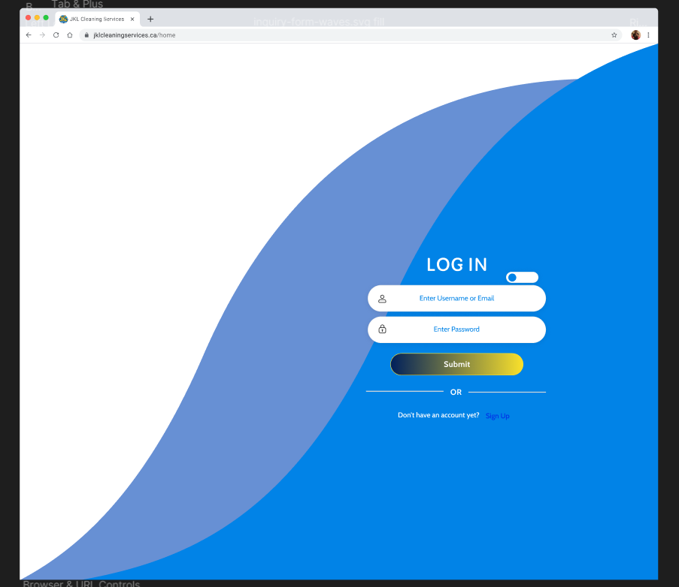

Figure 3. Log in page of JKL Cleaning Service Website.

* Figure 4 is the page where customers can sign up if they have not created an account.

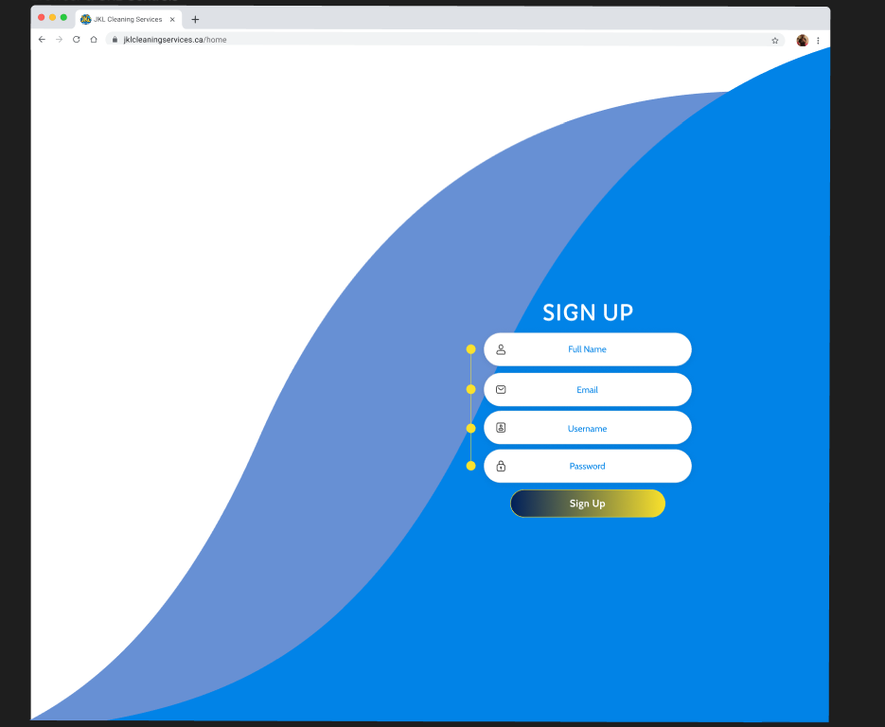

Figure 4. Sign Up page of JKL Cleaning Service Website.

* In Figure 5, the system will send a message to the customer if their account is valid or has been created.

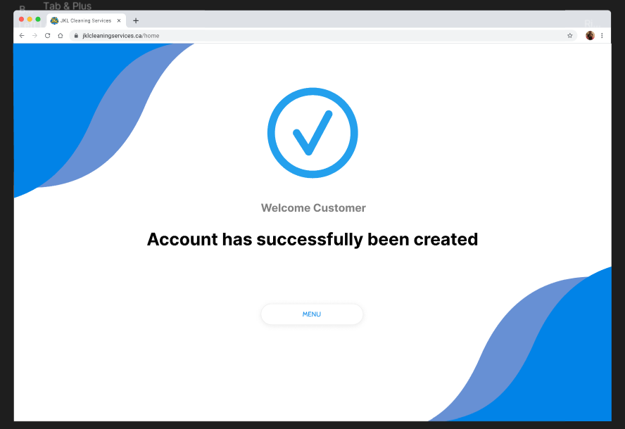

Figure 5. "Account Created" page of JKL Cleaning Service Website.

* In Figure 6, once they have created an account or logged in into their account, they will have access to the JKL Cleaning service website.

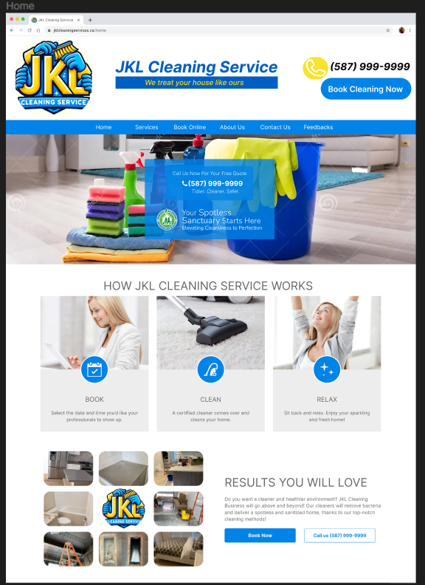

Figure 6. Home page of JKL Cleaning Service Website.

* In Figure 7, customers can see the cleaning services that is included within cleaning their premise.

Figure 7. "Services" page of JKL Cleaning Service Website.

* In Figure 8, customers view extra information about the JKL Cleaning Services Business.

Figure 8. "About Us" page of JKL Cleaning Service Website.

* In Figure 9, customers can contact us, email us, or message us if they have any questions or concerns.

Figure 9. "Contact Us" page of JKL Cleaning Service Website.

* In Figure 10, customers can see other customer’s reviews, customers can also rate us, or leave reviews about JKL Cleaning Service.

Figure 10. "Feedbacks" page of JKL Cleaning Service Website.

* In figure 11, figure 12, and figure 13, customers can book a cleaning by providing the essential information. Customers can view which day and time the Crew are busy or available to clean their premises. Once they have booked an appointment, the website sends a message confirming their appointment.

Figure 11."Book Online" page of JKL Cleaning Service Website.

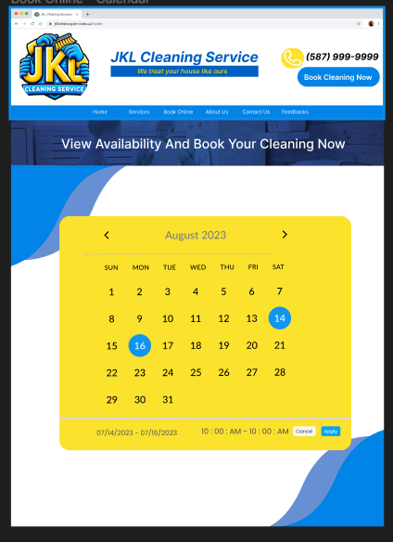

Figure 12. Calendar of JKL Cleaning Service Website.

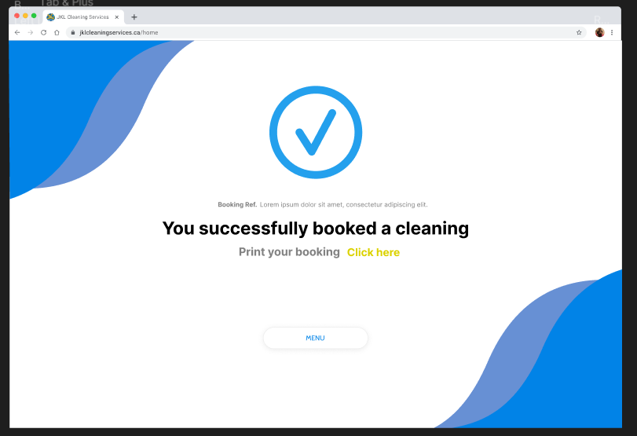

Figure 13. "Booked" page of JKL Cleaning Service Website.

* In figure 14, this is where the employees will have to login in order to access their account.

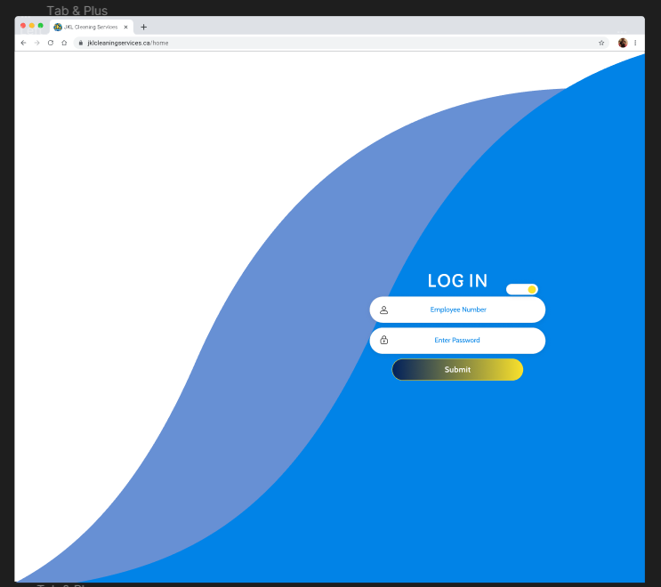

Figure 14. "Employee Log in" page of JKL Cleaning Service Website.

* In Figure 15, the employees can see their hours, their team, co-workers, how many houses they will be cleaning during that day, see their clients, and their information. Employees can also edit their profile, view reviews, or message co-workers.

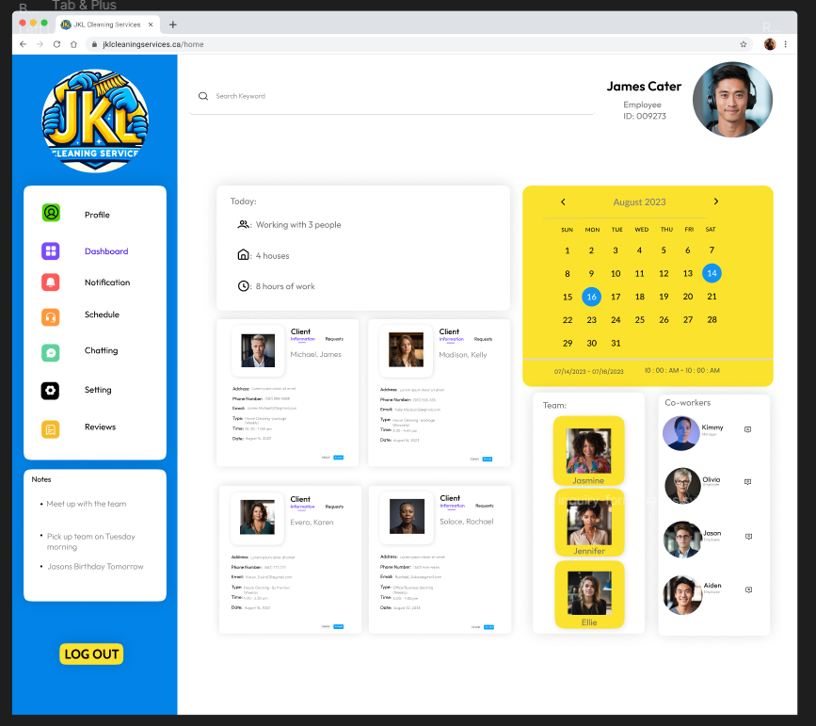

Figure 15. "Employee Dashboard" page of JKL Cleaning Service Website.

* In Figure 16, the manager can view the employee's information and the client's information. They have access to some features, such as dashboard, schedule, resumes, activity, and many more. Managers can also edit their profile, message clients, or employees.

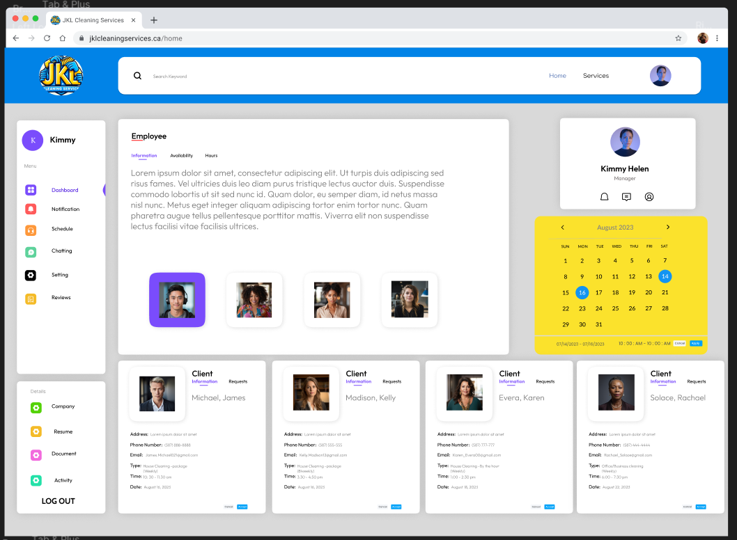

Figure 16. "Employee Dashboard - Information" page of JKL Cleaning Service Website.

* In Figure 17 and Figure 18, managers can also check the employee’s availability and can accept or cancel a client’s appointment if necessary.

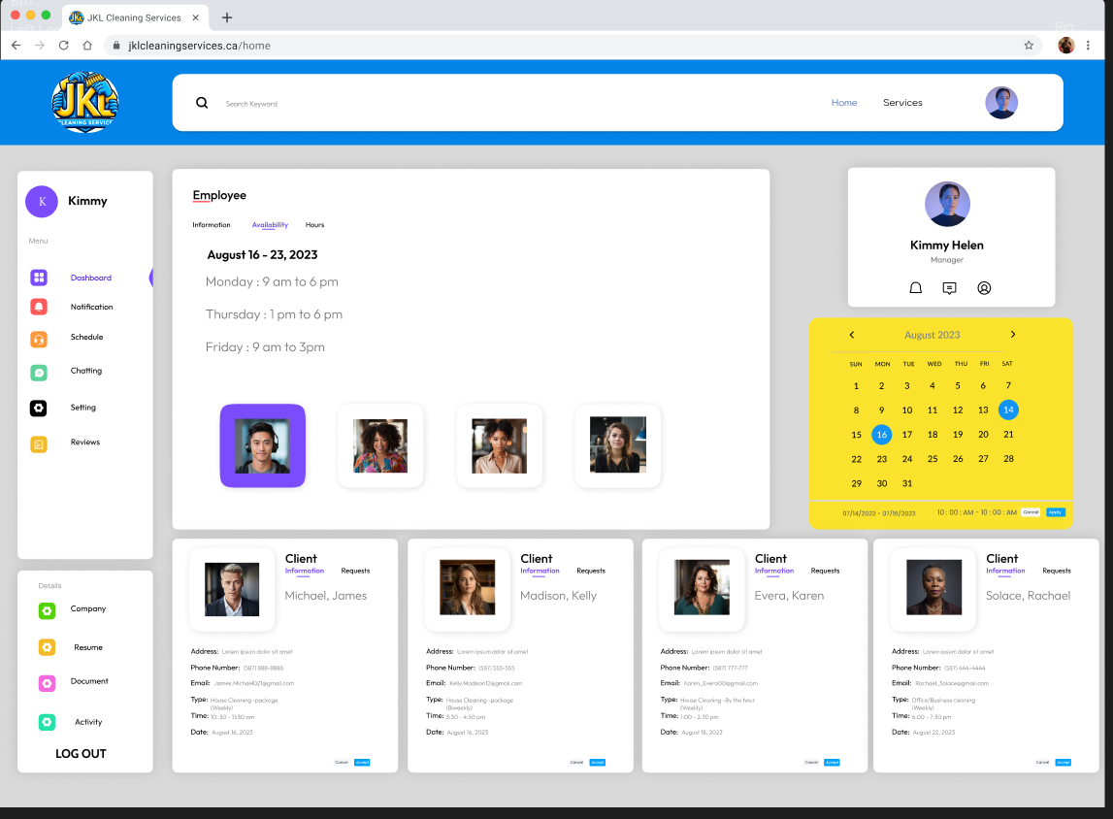

Figure 17. "Employee Dashboard - Availability" page of JKL Cleaning Service Website.

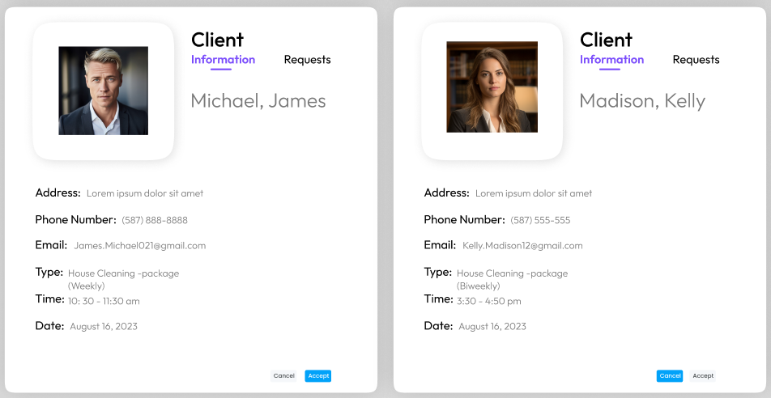

Figure 18. "Client Profile" page of JKL Cleaning Service Website.

* In Figure 19, managers can view the hours of any employee.

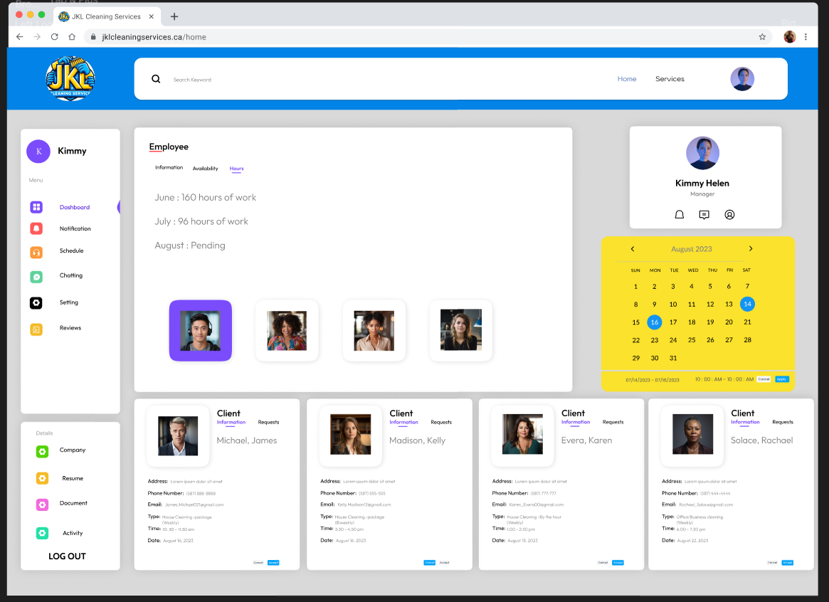

Figure 19."Employee - Hours" page of JKL Cleaning Service Website.

# Data Storage and Persistence

For the JKL Cleaning Service project, an effective data storage and persistence solution would involve a combination of a relational database and cloud-based file storage. Utilizing a relational database, such as MySQL, would be ideal for structured data management. This choice provides a robust framework for organizing data related to clients, cleaning schedules, employee information, and other pertinent details.

JKL Cleaning Service’s unique requirements will be reflected in the meticulously planned schema of the relational database when it is deployed. Tables for customers, staff members, services provided, and scheduling data will all be included in this schema, creating connections between these entities to create an extensive and linked data model. To maximize query performance and guarantee rapid and effective data retrieval, indexing algorithms will be used.

To manage unstructured data, a cloud-based file storage solution like Google Cloud Storage will be used in addition to the relational database. Images, other media assets, and files pertaining to cleaning service paperwork are included here. Because cloud-based storage is scalable, accessible, and long-lasting, JKL Cleaning may save and retrieve information with ease and take advantage of the redundancy and availability that cloud platforms offer.

Developing safe APIs to communicate with the relational database and cloud-based file storage is a necessary step in putting this solution into practise. To guarantee data security and privacy, access control and authentication procedures will be put in place. Referential integrity and coherence in the whole data management system will be preserved by establishing integration points between the database and file storage.

In summary, the chosen data storage solution for the JKL Cleaning Service project combines the strengths of a relational database for structured data and cloud-based file storage for unstructured data. This approach provides a flexible and scalable foundation for the project's data storage and persistence needs, enabling efficient management of diverse data types associated with cleaning services.

# Entity Diagram

Figure 20. Entity Relationship Diagram - JKL Cleaning Service

# Revised Class Diagram

Figure 21. Revised Class Diagram – JKL Cleaning Service

# System Architecture and Patterns

As explained in Chapter 14, System architectures and design patterns are fundamental aspects of software development, akin to a city's master plan and the recurring themes in architectural designs and furniture arrangements found in every room of a house, respectively [7]. System architecture serves as a city's master plan, providing a high-level overview of the organization and connectivity of the software system. For the JKL Cleaning Service project, the system architecture is structured into three tiers: a presentation layer housing the user interface, a logic layer handling processing, and a data layer storing information. This architectural design ensures a clear division of responsibilities, making implementation more manageable and enhancing reuse.

The Model-View-Controller (MVC) design pattern is aligned with this system architecture. MVC separates the user interface, business logic, and data structures, promoting independent creation and modification of system components. In the context of JKL Cleaning Service, employing the MVC design pattern ensures a clean and well-organized codebase, making the platform resilient, adaptable, and capable of evolving with changing business requirements.

System architecture focuses on the overall structure and functionality of the software system. It addresses high-level decisions such as database structure, user interfaces, and networking. For JKL Cleaning Service, the system architecture encompasses the web-based platform's structure, database schema, and interactions between different components.

Design patterns, on the other hand, provide specific solutions to recurring design problems at a smaller scale. They address issues within specific modules or components of the system [7]. In the case of JKL Cleaning Service, design patterns could be applied to handle specific challenges within the system architecture. For example, web application patterns, like the Model-View-Controller pattern, can be employed to manage user interactions and data. User interface design patterns, such as the Observer pattern, may enhance user experience by synchronizing different parts of the interface. Data patterns like the Repository pattern could ensure a structured and centralized approach to data storage, crucial for managing customer bookings, Employee details, and job-related data.

In summary, the system architecture serves as the city's master plan, organizing the entire software system, while design patterns provide specific solutions to design problems within that system. The chosen MVC design pattern for JKL Cleaning Service ensures a well-organized and scalable platform, and additional design patterns can be employed for specific functionalities like data storage, user interface management, and data synchronization. The combined use of system architecture and design patterns ensures that the JKL Cleaning Service platform is robust, adaptable, and capable of meeting evolving business needs.

## Sample Design Pattern for JKL Cleaning Service

**Pattern name:** Data patterns - Repository Pattern

**Problem:** Efficiently track and manage Employee's total hours worked based on their bookings.

**Motivation:** Ensure a structured and centralized approach to data storage, facilitating the calculation of Employee's total hours worked.

**Context:** Web-based platform for managing cleaning service bookings with a need for organized data handling.

**Forces:** Need for a systematic and centralized method to store and retrieve data related to Employee's work hours.

**Solution:** Implement the Repository Pattern to create a dedicated repository for Employee-related data, allowing streamlined access and manipulation of their total work hours.

**Intent:** Enhance the platform's ability to manage and calculate Employee's total hours worked by adopting a design pattern tailored for efficient data storage and retrieval.

**Pattern Name:** Data Repository Pattern

**Problem:** Efficiently manage customer bookings based on preferred dates, times, and property sizes.

**Motivation:** Enable systematic storage and retrieval of booking data for streamlined access and modification.

**Context:** Web-based platform for JKL Cleaning Service handling diverse booking-related information.

**Forces:** Need for structured and centralized data storage to enhance data management efficiency.

**Solution:** Implement a Data Repository Pattern to organize and store booking information systematically.

**Intent:** Facilitate organized data handling, ensuring quick access and modification of booking details.

# Sequence Diagrams

Figure 22. Employee - Add or Change Availability Sequence Diagram.

Figure 23. Customer - Write a Review Sequence Diagram.

Figure 24. Customer - Book Cleaning Appointment Sequence Diagram.

Figure 25. Manager - Add Employees Sequence Diagram.

Figure 26. Employee - Cancel Booking Appointment Sequence Diagram.

# Activity Diagrams

Figure 27. Customer Activity Diagram.

Figure 28. Employee Activity Diagram.

# Small System Prototype

Figma

Customer Flow: <https://www.figma.com/proto/S639npzBLRHkV9hZ6ZDMvw/JKL-CLEANING-SERVICE?type=design&node-id=6-3&t=LNwUExUk1RFWhr7c-1&scaling=min-zoom&page-id=0%3A1&starting-point-node-id=6%3A3&show-proto-sidebar=1&mode=design>

Employee Flow: <https://www.figma.com/proto/S639npzBLRHkV9hZ6ZDMvw/JKL-CLEANING-SERVICE?type=design&node-id=211-26033&t=LNwUExUk1RFWhr7c-1&scaling=min-zoom&page-id=0%3A1&starting-point-node-id=211%3A26033&show-proto-sidebar=1&mode=design>

Manager Flow: [▶ Page 1 - JKL CLEANING SERVICE (figma.com)](https://www.figma.com/proto/S639npzBLRHkV9hZ6ZDMvw/JKL-CLEANING-SERVICE?type=design&node-id=290-3749&t=BaKnqiRpzF7jMgNs-0&scaling=min-zoom&page-id=0%3A1&starting-point-node-id=6%3A3&show-proto-sidebar=1)

Presentation

Link: <https://youtu.be/8sZLdPA7yYc>

# Work Breakdown and Gantt Chart

## Work Breakdown

**JKL Cleaning Service Web Platform**

1. **Project Kickoff and Planning** 
   * 1.1 Conduct kickoff meetings with JKL to understand needs.
   * 1.2 Formulate the project team, assign roles, and set communication protocols.
   * 1.3 Create the initial project plan, outlining key tasks and responsibilities.
2. **Team Charter Finalization**
   * 2.1 Finalize Team Charter with input from the team and sponsors.
   * 2.2 Align team expectations with project goals for a unified approach.
   * 2.3 Distribute the finalized Team Charter to all team members.
3. **Design Document Revision**
   * 3.1 Finalize the design document with details on features and functionalities.
   * 3.2 Collaborate with JKL for input on key features and specific requirements.
   * 3.3 Begin incorporating feedback and refining the design document.
4. **Client Design Review**
   * 4.1 Present the final design document to JKL for review and feedback.
   * 4.2 Address client concerns and suggestions, making necessary adjustments.
   * 4.3 Compile feedback notes and prepare for the next development phase.
5. **Development - Online Booking Feature**
   * 5.1 Initiate development of the Online Booking feature, focusing on UI design.
   * 5.2 Integrate the feature with a secure database and conduct iterative testing.
   * 5.3 Refine the Online Booking feature based on early feedback.
6. **Development - Employee Management Feature**
   * 6.1 Progress with Employee Management portal development, ensuring secure logins.
   * 6.2 Implement tools for Employees to track work hours and report progress.
   * 6.3 Address feedback and refine the Employee Management feature.
7. **Development - Employee Management Feature**
   * 7.1 Continue refining the Employee Management portal based on ongoing feedback.
   * 7.2 Address outstanding issues related to schedule management and reporting tools.
   * 7.3 Conduct internal testing to ensure Employee Management functionality.
8. **Development - Notifications, Reviews, and Ratings Features**
   * 8.1 Initiate development of customer notification systems.
   * 8.2 Begin implementing Customer Reviews and Ratings feature, conduct initial testing.
   * 8.3 Continuously refine features based on iterative testing and user feedback.
9. **Technical Design Review**
   * 9.1 Conduct a technical design review to evaluate progress.
   * 9.2 Discuss solutions for identified technical challenges, make necessary adjustments.
   * 9.3 Document lessons learned and improvements for future development.
10. **Development - Notifications, Reviews, and Ratings Features**
    * 10.1 Continue refining customer notification systems.
    * 10.2 Enhance the Customer Reviews and Ratings feature based on feedback.
    * 10.3 Conduct comprehensive testing of the integrated features.
11. **Final Testing and Polishing**
    * 11.1 Conduct comprehensive testing of all features.
    * 11.2 Address remaining issues, bugs, and polish UI based on feedback.
    * 11.3 Prepare documentation for system maintenance and user guides.
12. **Acceptance Test Plan and Beta Installation**
    * 12.1 Develop an acceptance test plan to validate all features.
    * 12.2 Begin beta installation for initial testing, and address feedback.
    * 12.3 Prepare for the final presentation of the web platform.

## LOC Estimation Table

|  |  |
| --- | --- |
| **Function** | **LOC Estimate** |
| Online Booking | 4000 |
| Hours Tracking | 3000 |
| Customer Notifications | 2000 |
| Customer Reviews and Ratings | 3500 |
| Appointment Cancellation/Rescheduling | 2250 |
| Location-Based Booking | 3000 |
| Employee Cancellation | 2000 |
| Employee Profiles | 2750 |
| Interactive Pricing Calculator | 2400 |
| Appointment History | 2750 |
| Employee Management | 3500 |
| Customer Database | 2500 |
| Employee Database | 2400 |
| Total | 20000 |

Figure 29. LOC Estimation Table.

Total Person Months (pm) :

$$Total Person Months \left(pm\right)=Team Size ×2.5$$

$$12.5 pm=5 people ×2.5$$

Productivity Calculation:

Productivity (LOC/pm) = $\frac{Estimated LOC}{Total Person Months}$ = $\frac{20,000 LOC}{12.5 pm}$ = 1600 LOC/pm

Hence, the productivity (P) of our project is 1600 LOC/pm.

Effort Calculation:

$$Effort (person years)= =E= \frac{L^{3}}{P^{3}×t^{4}}$$

Where:

* E is the development effort in person years
* L is the Lines of Code (20,000 LOC)
* P is the productivity parameter (2500 LOC/pm) [7]
* t is the development time in years (2.5 months/12months)

$$E= \frac{{20,000}^{3}}{{\left(2500\right)}^{3}×{\left(\frac{2.5}{12}\right)}^{4}}=271,790.9 person years$$

$$E in person months=271,790.9 person years ×\left(\frac{12 months}{1 year}\right)=3,261,491 person months$$

## Gantt Chart

Note: For a better-quality view of the Gantt chart, the team has included a separate PDF file in landscape format.

Figure . JKL Platform Project Gantt Chart.

# Appendix

## Team Constitution

**Project Name:** JKL Cleaning Service Website

**Team Members:**

* Georcia Eugenio
* Lance Gonzales
* Pawandeep Kaur
* Navraj Singh
* Sehajbir Singh

**Purpose and Objectives:**

The purpose of this project is to create a web-based platform to enhance the experience for the client while improving and helping JKL Cleaning Service operate more efficiently. This will be the central hub for clients and Employees to communicate, book, request, pay, and manage cleaning needs.

**Roles and Responsibilities:**

* Researcher: All the team members (Each team member is equally involved in this process)
* Designer: All the team members (Each team member is equally involved in this process)
* Developer: All the team members (Each team member is equally involved in this process)
* Communicator: All team members are responsible for communicating with each other and communicating with the stakeholders for updates and concerns.

**Decision-Making Process:**

Decision making will be made by all the members who are involved in this project, making each team member have an equal say. When disagreements occur, as a team we are responsible for deciding in a term that will include everyone's viewpoint while reaching the desired outcomes we wanted.

**Meeting Schedule:**

Team meetings will regularly be held during class where each team member will meet in person discussing about the project. Additional meetings can be scheduled during weekends or when each team member is available if needed.

**Communication Plan:**

We will be using teams as our communication tool. When it comes to the client, we will be using our email to communicate with them. When urgent occurrences, phones calls or in-person meetings will be considered.

**Project TimeLine:**

A project TimeLine will be created based on the due date of the project and availability of each team member. Each team member will be expected to be responsible and meet the deadline that was given.

**Conflict Resolution:**

All team members will be addressing and resolving when a conflict occurs. As a team, we must consider everyone’s point of view and opinions while leading to the desired results we want.

**Work Quality and Standards:**

Each team member must have a high-quality work on their part of the project. We will review and provide each other with feedback to improve the project’s outcomes.

**Communication with Stakeholders:**

We will keep the communication with the stakeholders consistent and professional, the team will be communicating with the stakeholders to inform them about the process of the project. Not only will we be informing them about the project, but we would also ask them for feedback and concerns of the project, implementing them to the project if necessary.

**Expectations and Consequences:**

Each team member is required to be present in class and in meetings in order to be informed about the project’s development and progress. If a member is unable to attend the class or the meeting, they must inform other members about their absences. Unable to do so will be given a strike, if a member has had three strikes they will be removed from the group.

**Electronic Signatures:**

Sha Eugenio Date signed: October 15, 2023

Lance Gonzales Date signed: October 15, 2023

Sehajbir Singh Date signed: October 15, 2023

Navraj Singh Date signed: October: 15, 2023

Pawandeep Kaur Date signed: October 15, 2023

# Bibliography

[1] “JKL Cleaning Service in Calgary, AB | 4034742673 | 411.ca,” *411.ca*. https://411.ca/business/profile/7090226 (accessed Oct. 10, 2023).

[2] “UML Practical Guide - All you need to know about UML modeling,” Visual-paradigm.com, 2019. https://www.visual-paradigm.com/guide/uml-unified-modeling-language/uml-practical-guide/ (accessed Oct. 11, 2023).

[3] Creately, “UML Class Diagram Relationships Explained with Examples | Creately,” creately.com, Jul. 01, 2022. https://creately.com/guides/class-diagram-relationships/ (accessed Oct. 11, 2023).

[4] “Relationships in class diagrams,” www.ibm.com, Sep. 25, 2020. https://www.ibm.com/docs/en/rational-soft-arch/9.7.0?topic=diagrams-relationships-in-class (accessed Oct. 11, 2023).

[5] “How to Write a Software Proposal (With Examples),” Proposify [Free Trial]. https://www.proposify.com/blog/how-to-write-a-software-proposal (accessed Oct. 11, 2023).

[6] H. Dhaduk, “Tech Stack 2023: A Guide to Choosing the right software stack,” Simform - Product Engineering Company, Aug. 16, 2022. https://www.simform.com/blog/tech-stack/ (accessed Oct. 12, 2023).‌

[7] R. S. Pressman and B. R. Maxim, Software engineering: a practitioners approach. New York, Ny: Mcgraw-Hill Education, 2020.

[8] Dreamstime, “Stock Photos And Royalty-Free Images By Dreamstime,” Dreamstime.com, 2019. <https://www.dreamstime.com/> (accessed Oct. 20, 2023).‌

‌